Speak Week 2023/24 Report  
**Written by Parker Robinson, SU Voice Coordinator**

Contents

* Introduction
* Demographics of Responders
* Main Themes
* Academic Experience: Learning Infrastructure
* Academic Experience: Student Development and Support
* Food and Outlets
* Parking and Transportation
* Student Sense of Belonging
* Conclusion
* Appendix: School and Individual Student Group Summaries
  + CSAD
  + CSESP
  + CSM
  + CST
  + CSSHS
  + Student Groups

# Introduction

Speak Week 2024 was the first iteration of Cardiff Met SU’s Speak Week campaign, with the intention to re-deliver annually to enable comparisons of data and trends in student issues. The campaign took place from 19th – 23rd February, with additional targeted surveying conducted the following week in schools with lower response rates to ensure fairer representation in our final report.

Students were surveyed through a physical postcard and a digital form counterpart. To ensure we can create strategies to support specific groups of students, the questionnaire began with asking identifiers such as; Student Number, Gender, Ethnicity, School, Year of Study, and additional characteristics such as LGBT+, Mature, and International.

Note that some students declined to respond with their student number or additional identifiers. Where this is covered in the report this group of students is referred to as “not listed.”

The main body of the question asked students to respond to the question “If You Ran the University, What Would You Change?” Students were encouraged to give as much detail regarding the elements of their Cardiff Met Experience that they would like to see changed.

During the week, physical surveying took place on both campuses simultaneously. Three stalls were delivered each day. On Llandaff we held physical stalls in close vicinity to each school, utilizing the Management buildings foyer, outside the library, the CSAD Heartspace, and the CST Nexus. On Cyncoed, we held physical stalls outside the SU Shop and within the SU Bar and Kitchen Centro.

An incentive was used to encourage higher turnout. A single student chosen at random, who filled out the form would receive 2 varsity Tickets.

# Demographic of Responses Breakdown

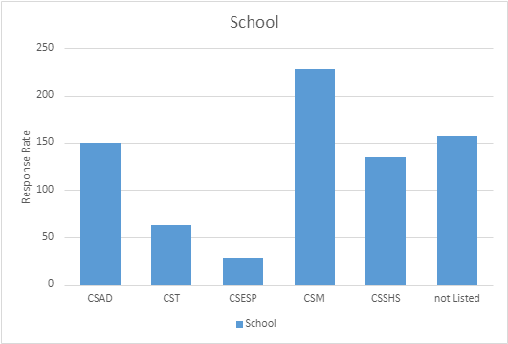

Fig.1 Response Rate Per School

We received 773 responses during the surveying period. Whilst we targeted each school specifically, we saw a low turnout from CSESP. 157 students did not list their school; however, campus site of submission was recorded for these and 30 were collected from Cyncoed, and 120 were from Llandaff.

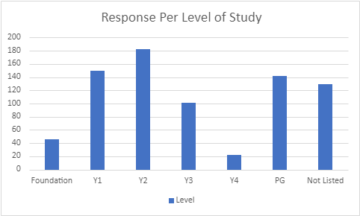

Fig 2. Response Rate Per Level.

Foundation 46. Undergraduate 456. Postgraduate 142. 129 Not Listed.

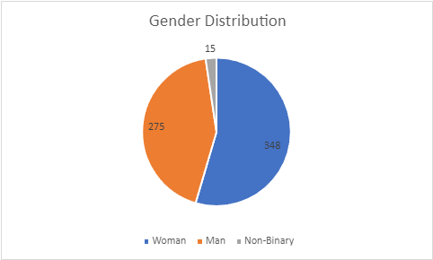

Fig 3. Response Rate Per Gender

275 Men. 348 Women. 15 non-binaries. 124 Not listed.

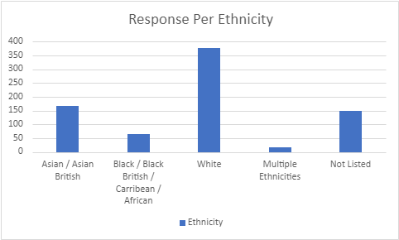

Fig.4 Response Rate Per Ethnicity.

166 Asian / Asian British. 65 Black, Black British / Carribean / African. White 376. Multiple Ethnicities 16. Not Listed 150.

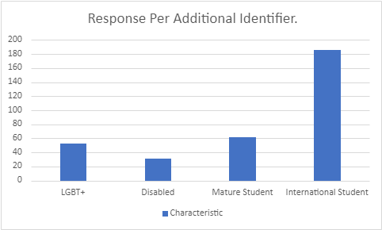

Fig 5. Responses per Additional Identifiers

53 LGBT+. 31 Disabled. 62 Mature Students. 186 International Students.

# Main Themes

Speak Week data was analyzed through two methods;

1. Creating an overall picture of student issues on a school level.

Student responses have been compiled on a school level to enable university staff and the SU School Representative structure to view data most relevant to their students.

1. Analyzing responses by theme.

Student responses have been compiled on a theme basis to create an image of the entire institution, where data has been assessed and assigned to a fitting category. This will enable a clearer picture of the issues affecting our current members. Students covered several themes in each of their responses, so each individual theme raised has been counted and separated out.

Following the Analysis of our first iteration of Speak Week, we have identified the following major themes:

1. Academic Experience: Learning Infrastructure (443)
2. Academic Experience: Student Development and Support (219)
3. Food and Outlets (215)
4. Parking and Transportation (188)
5. Student Belonging (178)

It is worth noting that within each theme, there are prevalent sub-themes which we will elaborate on further within each section.

# Academic Experience: Learning Infrastructure

This section pertains to elements of the Academic experience which are necessary to the learning experience and enable our students to engage in their education. This is our largest theme encapsulating several sub-themes. A few sub-themes have been omitted due to their low submission rate, but feedback has been passed on to their respective School Representatives.

**Timetabling (126)**

There were 126 comments surrounding timetabling, with 2 strong narratives coming from student responses. Firstly, Students acknowledged and are frustrated with the structure of their academic days, citing that they would often have long breaks (1-2 hours) between timetabled content. Students were firm in their need to maintain smaller 15-minute breaks but want their days to be more compact. Secondly, regarding Timetabling, students felt academic content scheduled after 5pm was a detriment to their personal and professional lives. Students often must make a conscious decision between attending academic content and attending professional commitments.

**Facilities (64)**

A broad theme, but this covers student views surrounding amenities and buildings on campus they would either like to see, or have improved;

Students highlighted a need for prayer rooms to be more readily available and open on weekends.

Designated smoking areas on both campus sites have been a common theme in responses.

Students would like to see more bike storage on campus.

Students would also like to see more maps on campus to enable them to find different buildings and services.

Students have also raised the idea that they would like to see Sleeping pods available on campus.

Students expressed dissatisfaction with the signage on the windows of The Gallery, whilst signage was removed, they were clear they did not want this to recur.

**Communication (36)**

Responses surrounding communication revolved mostly around 2 narratives; receiving timely, clear, concise emails from university staff and secondly; a lack of communication regarding changes to course content, graduation, student events, and student support.

**Study Spaces (22)**

Our CSAD students have raised a lack of plugs/ outlets within their study spaces which has impacted their ability to maintain a consistent study session. Outside of CSAD, a consensus amongst the students is that there are limited quiet study spaces, or individual study spaces. Students mentioned they feel there are no study spaces outside of commercial outlets, which are typically noisy or feature pressure to move on and out of the space.

**Online Learning (19)**

Student responses to Online learning was mixed, whilst a minority of students valued the availability of online classes and requested more. Most of our responders wanted the complete removal of online classes, but the consistent between the two camps was that they would like more online content (recorded content) utilized to complement their learning.

**Assessment (17)**

Regarding assessments, our students wanted to see more clarity over how assessed group work relates to an individual's performance. They have expressed anxiety with the notion their attainment can be deeply impacted by the underperformance of a peer.

**Learning Resources (15)**

CSAD student responders have outlined a need for increased availability of supplies needed for their courses; paint brushes, paint, and general art supplies. CSAD also feel they need additional equipment such as scanners to enable their work.

**Course Costs (12)**

Building on Learning Resources, our students also demonstrated frustration with unexpected course costs, especially regarding printing. Students have commented on a need for transparency with their fee usage, explored in the following response theme.

**Tuition (12)**

Within course costs and tuition themed responses, it is clear our students need further transparency in what they should receive in return for paying tuition. Students have felt their tuition fee should cover costs like printing, and transport between campus sites.

Also, linking closely to timetabling, our students are demonstrating a cost exercise for time they have timetabled for academic content. Many of our respondents said they feel that the academic year should span longer over the year as they feel they are only paying for 9 months.

**Welsh (8)**

Students exhibited a passion to be able to study and submit fully in the Welsh Language. Students cited the current provision of Welsh language support as unsubstantial, and the opportunity to learn in Welsh as non-existent.

**Library (5)**

Student feedback on the library centered on its opening hours, where they requested the service to maintain 24 hours and 7 days a week opening times, and to look at methods to reduce noise levels within the space.

# Academic Experience: Student Development and Support

**Professional Development (40)**

Students have voiced a want to receive more professional development whilst they are at university. There is a clear desire to see more professionals from different industries to get involved with delivering content to students. Alongside these students would also like more support in the application and sourcing of job opportunities from the university.

**Student Support (70)**

Within student support themed responses, we saw a few narratives.

The first being that international students do not feel they are being adequately supported with the transition to UK-based study. From comments we can see that international students felt they hit a wall from how much they had to relearn regarding best academic practice and felt there was little in terms of resources and student support vehicles to help them. Building on this, these students feel their induction did not best equip them for Uk studying, nor did it allow them to meet other students in a way which would foster networking / friendships.

**Students’ Union (46)**

The Students’ Union has come up as a concern for many of our members, where they mention a dissatisfaction with the size and scale of the services on offer. With comparisons drawn to our colleagues at Cardiff University Students’ Union, our students clearly feel they are missing additional elements of their SU experience.

Our students have demonstrated they would like to see a larger SU on their campus, with Llandaff students specifically citing they would like an SU bar and social space. In terms of our engagement service offers, it is clear our students would like to see a wider variety and higher quality of societies, a wider depth of advice and guidance, and stronger voice initiatives.  
  
In terms of our commercial outlets, Students feel that our provisions are inadequate in terms of service hours, food variety, quality and events offered within the Centro space.

**Placements (17)**

Students expressed a concern with balancing placements alongside commitments to core study, and additional work outside of university life to ensure they can afford housing. They also expressed an interest in seeing more campus-based placement opportunities available.

**Gym (10)**

Students voiced that the Gym facilities on Llandaff campus are small and not equipped to support the student community based on site. Students felt that accessing the gym was difficult due to having to book a space, and that the costs for joining the gym need to be reduced or preferably removed entirely.

# Food and Estates.

**Food Prices (173)**

The costs of food at on-site outlets came up as one of our most predominant themes within our student responses. Students have often cited that they feel the university is charging high food prices, and this has caused students to often forgo a meal. This is a sentiment shared between both campus sites. Students feel there are not any clear steps from the university to offer discounts, or ‘meal deal’ options. Students also feel that there is also a steep price in terms of accessing fruit, and that junk food snacks are seen as more value for money than the healthier alternatives.

**Food Variety (90)**

In the same vein as food costs, the variety of food has come up repeatedly within the response rate of students. Students feel that the food options provided are limited, often just a sandwich and drink. Students would like to see more global food available in outlets and an increase in the amount of hot food available. There is also a clear desire for healthier meals.

**Smoking Areas (8)**

Responders have also demonstrated a desire for a smoking area on both campuses.

# Parking and Transportation

**Parking (125)**

Parking has come out as a strong theme, with a slightly different view on each campus site. On Llandaff students have told us there is an extreme lack of parking on site and in the local area. As they see the bus systems as undependable, they do not see this as a strong alternative for travel. The parking costs are also considered too high, and students would value cheaper parking and the removal of permits. Students writing within their responses have also demonstrated they often will make conscious decisions to avoid coming on to campus due to the lack of availability of parking – as this will impact their ability to then travel to work commitments following university.

**Bus (63)**

With regards to buses, two themes stood out. Students are voicing their concern about the dependability of the buses, as they are often late and at times which do not enable students to make it to lectures or work commitments on time. As the buses are considered undependable, they are not enabling students to get between campus sites easily. Students have cited this as causing them to not engage in extracurricular activities like sport.

Students also said they would like to see a consistent offering of the MetRider pass for students who are older than 22. Alongside this student view the bus services as too expensive.

# Student Belonging

**Events (79)**

Responding in their comments, students mentioned they would like to see more events hosted by both the University and the Students’ Union which enable them to meet others, share cultural identities, and more opportunities to celebrate their academic achievements at the end of a year.

**Social Spaces (51)**

Students raised feel there is a lack of social spaces on both campus sites referring specifically to not having spaces to relax, socialize or utilize as a break space.

Regarding Cyncoed, the SU Centro bar has been highlighted as the key social space – however students feel the space could be larger.

Llandaff students feel there is a lack of a distinct social space on their campus. Repeatedly the students have raised they would like a bar, or a non-academic centered space which enables them to build relations with each other and between academic staff.

CSSHS (Llandaff) have also raised they do not have a social space, or large study area like the other schools on site.

**Sports (42)**

Llandaff Students would like to see more offerings of sport on the campus site, citing that it is difficult to engage with sport due to transport issues at the cyncoed site.

There is a view that sports teams are treated unfairly compared to others – discussing that some teams are prioritized over others.

Students also feel that the timetables are not flexible enough to support them in engaging in sports activities, as training sessions often happen early in the morning at times when specific bus services are not running. Wednesday afternoons have also been raised as not being kept free to enable students to engage in BUCS.

Students also feel the Cyncoed outlet offers are not tailored to the high athlete population which studies there. Students felt that the campus should have more of a nutritional awareness.

**Global Issues (28)**

Our international student community would like to see more opportunities to share and partake in cultural activities. Citing that a part of the appeal of Cardiff Met was the opportunity to engage in new cultures.

International Students have also raised they feel an inadequate level of support for transitioning to UK based studies, including; housing guidance, employment opportunities, and academic culture.

Additionally, our international students would value more opportunities or demonstrations of using the online assessment submission portals.

**Inclusivity (17)**

CSAD would like to see an inclusion of gender-neutral toilets.

Students have raised they would like to see representative roles for different student groups to tackle issues relevant to those groups. I.e., a Womens officer, LGBT+ Officer etc.

Disabled access to areas of campus have been described as inaccessible, and disabled parking spaces need raising.

Students have also raised that there is an inconsistent approach from teaching staff regarding accessibility in learning. I.e., lecturers not utiluising captions, microphones, following learning support plans.

# Conclusion

Our members are a constantly evolving and diverse group of students. Their needs and priorities will shift throughout the academic year and reflect local and national politics. This report outlines the surface level thoughts of our members and how they would like to see their university experience. Utilized in our new Sabbatical Officer induction, a set of priorities will be designed by the Students’ Union to challenge and support the university in making changes in the interest of our members.

In future iterations, this report will feature two parts;

1. Speak Week survey results, with highlights of trends and themes within different schools and the university.
2. The results of focus groups conducted explore the root of the issues raised from speak week.

# Appendix: School and Individual Student Group Summaries

## CSAD School Summary

**Academic Experience: learning Infrastructure**

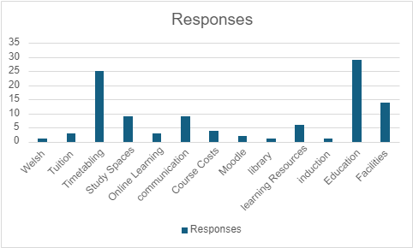

Welsh (1) Tuition (3) Timetabling (25) Study Spaces (9) Online Learning (3) Communication (9) Course Costs (4) Moodle (2) Library (1) Learning Resources (6) Induction (1) Education (29) Facilities (14)

**Academic Experience: Student Development and Support**

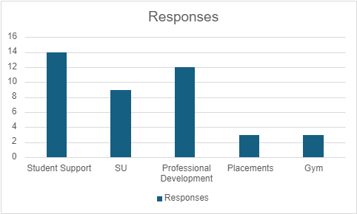

Student Support (14) SU (9) Professional Development (12) Placements (3) Gym (3)

**Food and Outlets**

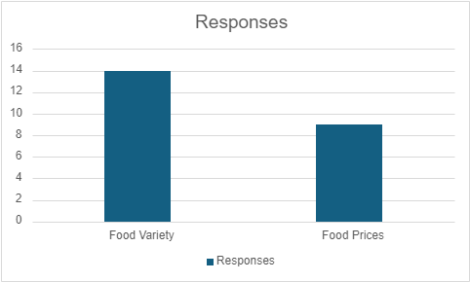

Food Variety (22) Food Prices (36)

**Parking and transport**

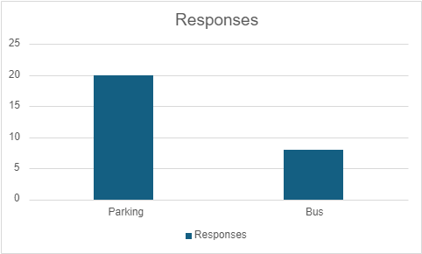  
Parking (20) Bus (8)

**Student Belonging**

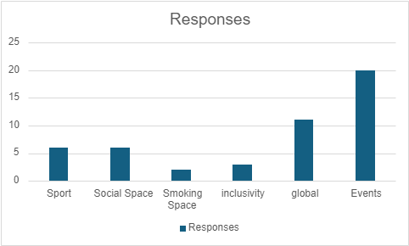  
Sport (6) Social Space (6) Smoking Space (2) Inclusivity (3) Global (11) Events (20)

## CSESP School Summary

**Academic Experience: learning Infrastructure**

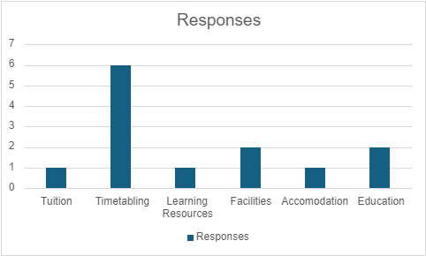

Tuition (1) Timetabling (6) Learning Resources (1) Facilities (2) Accommodation (1) Education (2)

**Academic Experience: Student Development and Support**

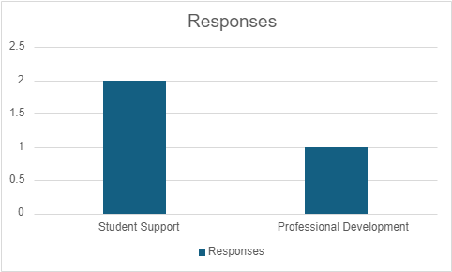

Student Support (2) Professional Development (1)

**Food and Outlets**

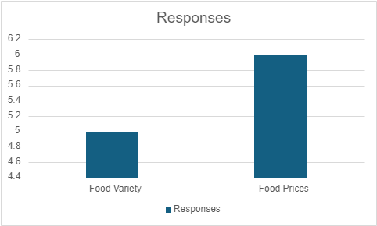

Food Variety (5) Food Prices (6)

**Parking and transport**

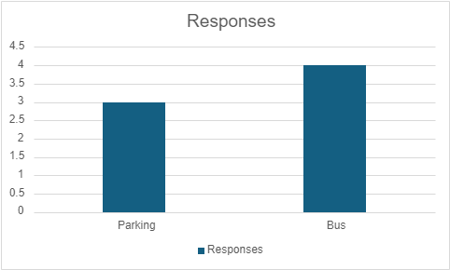

Parking (3) Bus (4)

**Student Belonging**

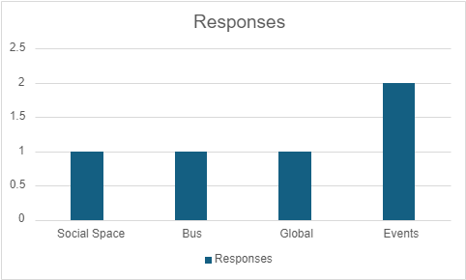

Social Space (1) Sport (1) Global (1) Events (2)

## CSM School Summary

**Academic Experience: learning Infrastructure**

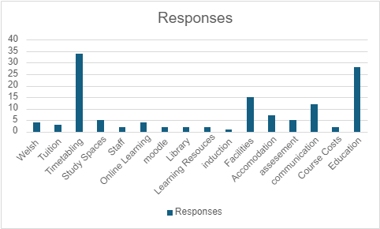

Welsh (4) Tuition (3) Timetabling (34) Study Spaces (5) Staff (2) Online Learning (4) Moodle (2) Library (2) Learning Resouces (2) Induction (1) Facilities (15) Accommodation (7) Assessment (5) Communication (12) Course Costs (2) Education (28)

**Academic Experience: Student Development and Support**

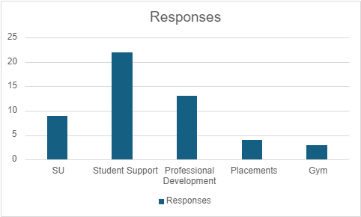

SU (9) Student Support (22) Professional Development (13) Placements (4) Gym (3)

**Food and Outlets**

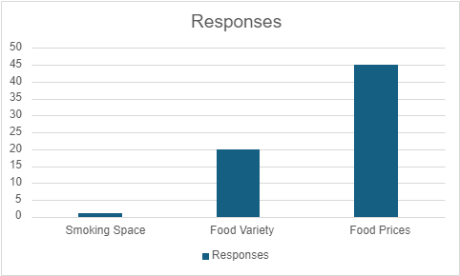

Smoking Space (1) Food Variety (20) Food Prices (45)

**Parking and Transport**

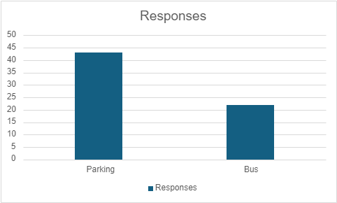

Parking (43) Bus (22)

**Student Belonging**

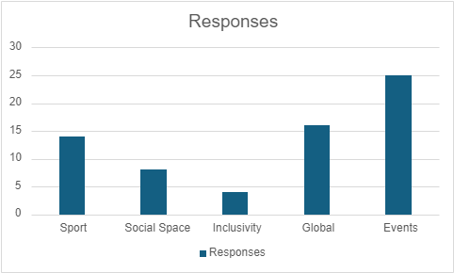

Sport (14) Social Space (8) Inclusivity (4) Global (16) Events (25)

CST School Summary

**Academic Experience: learning Infrastructure**

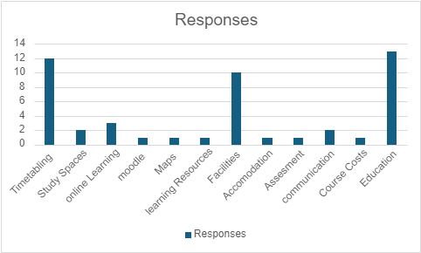

Timetabling (12) Study Spaces (2) Online Learning (3) Moodle (1) Maps (1) Learning Resources (1) Facilities (10) Accommodation (1) Assessment (1) Communication (2) Course Costs (1) Education (13)

**Academic Experience: Student Development and Support**

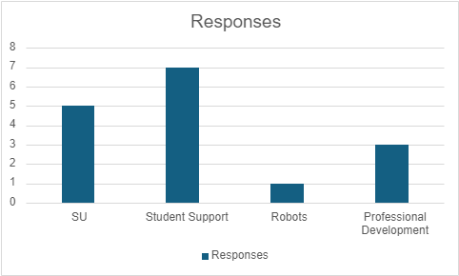

SU (5) Student Support (7) Robots (1) Professional Development (3)

**Food and Outlets**

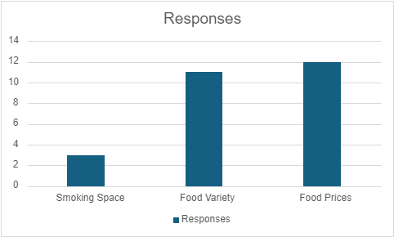

Smoking Space (3) Food Variety (11) Food Prices (12)

**Parking and transport**

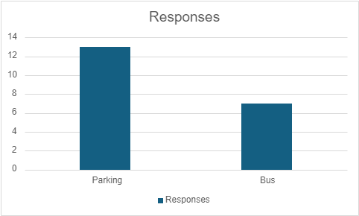

Parking (13) Bus (7)

**Student Belonging**

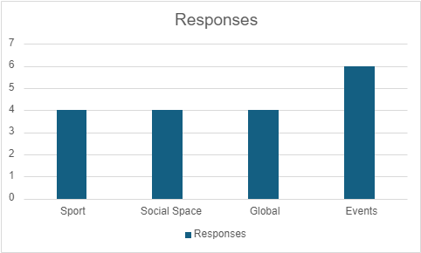

Sport (4) Social Space (4) Global (4) Events (6)

## CSSHS School Summary

**Academic Experience: learning Infrastructure**

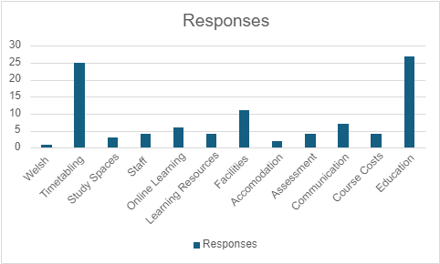

Welsh (1) Timetabling (25) Study Spaces (3) Staff (4) Online Learning (6) Learning Resources (4) Facilities (11) Accommodation (2) Assessment (4) Communication (7) Course Costs (4) Education (27)

**Academic Experience: Student Development and Support**

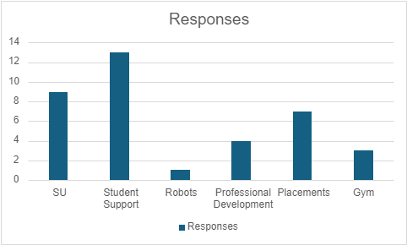

SU (9) Student Support (13) Robots (1) Professional Development (4) Placements (7) Gym (3)

**Food and Outlets**

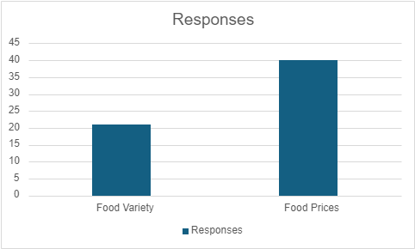

Food Variety (21) Food Prices (40)

**Parking and transport**

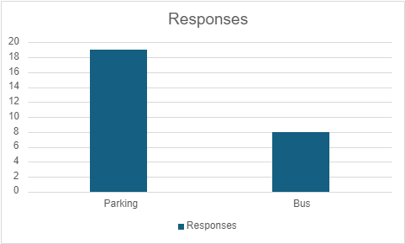

Parking (19) Bus (8)

**Student Belonging**

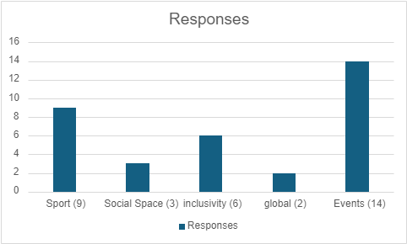

Sport (9) Social Space (3) Inclusivity (6) Global (2) Events (14)

## Individual Student Group Summaries

### **Male Students**

**Academic Experience: Learning Infrastructure**

Welsh (3) Tuition (3) Time Tabling (32) Study Spaces (13) Staff (4) Online Learning (11) Moodle (1) Library (3) Learning Resources (7) Induction (1) Facilities (23) Accommodation (6) Assessment (7) Communication (14) Course Costs (7) Education (44)

**Academic Experience: Student Development and Support**

Student Support (28) Gym (7) Students’ Union (13) Placements (8) Professional Development (16)

**Food and Outlets**

Food Variety (41) Food Prices (65) Smoking Spaces (1)

**Parking and Transportation**

Bus (20) Parking (49)

**Student Sense of Belonging**

Events (27) Inclusivity (8) Global (17) Social Space (16)

### Non-Binary Students

**Academic Experience: Learning Infrastructure**  
Time Tabling (3) Online Learning (3) Learning Resources (1) Facilities (1) Communication (1) Education (7)

**Academic Experience: Student Development and Support**

Student Support (1)

**Food and Outlets**

Food Variety (5) Food Prices (6)

**Parking and Transportation**

Bus (1)

**Student Sense of Belonging**

Events (1) Global (1)

### **Female Students**

**Academic Experience: Learning Infrastructure**

Welsh (2) Tuition (6) Maps (1) Time Tabling (68) Study Spaces (25) Staff (1) Online Learning (7) Moodle (5) Library (4) Learning Resources (8) Induction (1) Facilities (38) Accommodation (10) Assessment (4) Communication (18) Course Costs (7) Education (53)

**Academic Experience: Student Development and Support**

Student Support (31) Gym (3) Students’ Union (25) Placements (9) Professional Development (18)

**Food and Outlets**

Food Variety (32) Food Prices (77) Smoking Spaces (4)

**Parking and Transportation**

Bus (30) Parking (58)

**Student Sense of Belonging**

Events (39) Inclusivity (9) Global (25) Social Space (13)

### Asian / Asian British Students

**Academic Experience: Learning Infrastructure**

Welsh (1) Tuition (2) Time Tabling (31) Study Spaces (14) Staff (1) Online Learning (1) Library (2) Induction (1) Facilities (15) Accommodation (7) Assessment (6) Communication (11) Course Costs (1) Education (27)

**Academic Experience: Student Development and Support**

Student Support (18) Gym (1) Students’ Union (14) Placements (7) Professional Development (10)

**Food and Outlets**

Food Variety (16) Food Prices (33) Smoking Spaces (2)

**Parking and Transportation**

Bus (13) Parking (36)

**Student Sense of Belonging**

Events (13) Inclusivity (5) Global (6) Social Space (10)

### **Black / Black British/ Caribbean**

**Academic Experience: Learning Infrastructure**

Welsh (2) Tuition (2) Time Tabling (16) Study Spaces (4) Moodle (1) Facilities (7) Accommodation (3) Communication (2) Education (7)

**Academic Experience: Student Development and Support**

Student Support (10) Students’ Union (4) Placements (1) Professional Development (5)

**Food and Outlets**

Food Variety (5) Food Prices (19)

**Parking and Transportation**

Bus (9) Parking (7)

**Student Sense of Belonging**

Events (11) Global (4) Social Space (2)

### Multiple Ethnicities / Other

**Academic Experience: Learning Infrastructure**  
Tuition (1) Time Tabling (2) Staff (1) Online Learning (1) Learning Resources (1) Facilities (2) Accommodation (1) Communication (2) Course Costs (1) Education (4)

**Academic Experience: Student Development and Support**

Student Support (4) Professional Development (1)

**Food and Outlets**

Food Variety (1) Food Prices (6)

**Parking and Transportation**

Bus (3) Parking (8)

**Student Sense of Belonging**

Events (3) Global (2)

### **White**

**Academic Experience: Learning Infrastructure**

Welsh (2) Tuition (6) Time Tabling (53) Study Spaces (21) Staff (4) Online Learning (16) Moodle (6) Library (4) Learning Resources (14) Induction (1) Facilities (39) Accommodation (3) Assessment (6) Communication (21) Course Costs (4) Education (70)

**Academic Experience: Student Development and Support**

Student Support (36) Gym (8) Students’ Union (21) Placements (8) Professional Development (21)

**Food and Outlets**

Food Variety (20) Food Prices (96) Smoking Spaces (3)

**Parking and Transportation**

Bus (27) Parking (53)

**Student Sense of Belonging**

Events (47) Inclusivity (12) Global (15) Social Space (12)

### **Disabled Students**

**Academic Experience: Learning Infrastructure**

Tuition (2) Time Tabling (6) Study Spaces (1) Moodle (1) Learning Resources (2) Facilities (1) Communication (3) Course Costs (1) Education (6)

**Academic Experience: Student Development and Support**

Student Support (1) Students’ Union (1) Placements (1) Professional Development (1)

**Food and Outlets**

Food Variety (8) Food Prices (11)

**Parking and Transportation**

Bus (6) Parking (7)

**Student Sense of Belonging**

Events (4) Inclusivity (2) Global (1)

### **International Students**

**Academic Experience: Learning Infrastructure**

Welsh (1) Tuition (1) Time Tabling (38) Study Spaces (15) Staff (1) Online Learning (1) Library (1) Learning Resources (1) Facilities (12) Accommodation (12) Assessment (7) Communication (4) Education (18)

**Academic Experience: Student Development and Support**

Student Support (22) Gym (1) Students’ Union (15) Placements (6) Professional Development (11)

**Food and Outlets**

Food Variety (15) Food Prices (22) Smoking Spaces (1)

**Parking and Transportation**

Bus (20) Parking (38)

**Student Sense of Belonging**

Events (22) Inclusivity (2) Global (12) Social Space (12)

### **LGBT+ Students**

**Academic Experience: Learning Infrastructure**

Tuition (2) Time Tabling (8) Study Spaces (3) Online Learning (2) Moodle (1) Learning Resources (4) Facilities (5) Communication (3) Education (11)

**Academic Experience: Student Development and Support**

Student Support (6) Gym (1) Students’ Union (3) Placements (1) Professional Development (4)

**Food and Outlets**

Food Variety (12) Food Prices (16) Smoking Spaces (1)

**Parking and Transportation**

Bus (3) Parking (11)

**Student Sense of Belonging**

Events (3) Inclusivity (1) Global (5)

### **Mature Students**

**Academic Experience: Learning Infrastructure**

Tuition (1) Time Tabling (13) Study Spaces (1) Staff (1) Online Learning (3) Learning Resources (1) Facilities (5) Assessment (3) Communication (3) Course Costs (2) Education (18)

**Academic Experience: Student Development and Support**

Student Support (6) Students’ Union (1) Professional Development (7)

**Food and Outlets**

Food Variety (11) Food Prices (22)

**Parking and Transportation**

Bus (3) Parking (10)

**Student Sense of Belonging**

Events (7) Inclusivity (1) Global (8) Social Space (2)